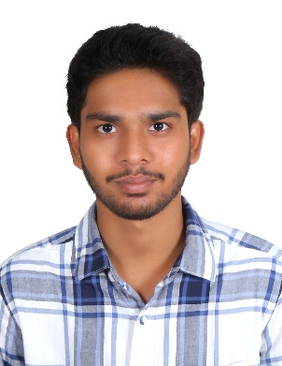
SAI MOKSHAGNA JAMALPUR
+91-7780574700
jsaimokshagna@gmail.com
https://www.linkedin.com/in/jamalpur-sai-mokshagna-a6b195289/
Career Objective:
To secure an entry-level position where I can apply my technical skills and continuously learn, while contributing to the growth of the organization. Eager to gain hands-on experience and build a strong professional foundation.
Education:
Course | Branch | University Board | Years of Study | Percentage/Grade
B.Tech | Computer Science | JNTUH | 2023-2027 | 7GPA
Intermediate | MPC | Board of Intermediate Education | 2021-2023 | 89.8%
10th |  | Central Board of Secondary Education | 2020-2021 | 83%
Projects:
- Digital Dots (3 months internship):
1. Moderated video content to ensure adherence to community guidelines.
2. Utilized strong analytical skills to review and evaluate video content.
3. Demonstrated attention to detail in managing and reviewing large volumes of video content.
- Weather App
1. Developed a Weather App using Node.js and integrated Weather API for real-time data.
2. Hosted the application on Vercel for seamless deployment and scalability.
3. Implemented JDBC for database connectivity to store and retrieve weather data.
- Hypothesis Testing
1. Conducted hypothesis testing to validate assumptions and draw meaningful conclusions from data.
2. Performed thorough data cleaning to ensure data quality, accuracy, and reliability.
3. Applied statistical methods to test hypotheses and measure significance.
Certifications:
- Excel Skills Job Simulation- JPMorgan
- Cyber Job Simulation- Deloitte
- Google AI Essentials- Coursera
- Communication Skills- TCS
- DevOps using HCL DevOps Deploy under Project Sunshine- HCL Tech
Technical Skills:
- Programming Languages: Python, C language, Java, HTML, CSS
Hobbies:
- Watching movies
- Playing Badminton
Interest:
- Writing stories
Languages:
- Telugu- Native proficiency
- English- Professional proficiency
- Hindi- Professional proficiency
Declaration:
I hereby declare that the information provided is true to the best of my knowledge.

Sai Mokshagna Jamalpur

